Ai Tools For Front-End Developers

Introduction
Artificial Intelligence (AI) is playing an important role in modern front-end development. AI tools help developers create user interfaces faster, write clean code, reduce errors, and improve productivity. These tools are widely used for code generation, UI design, testing, and debugging. Today, AI-powered tools are becoming an essential part of a front-end developer’s workflow.

AI Tools Used by Front-End Developers

1. AI Code Assistance Tools
These tools help developers write code efficiently by providing smart suggestions.
- GitHub Copilot
An AI-powered code assistant that suggests HTML, CSS, JavaScript, and React code inside the code editor.
- Tabnine
Helps with intelligent code completion and improves coding speed.
- Codeium
A free AI tool that assists in writing and refactoring front-end code.

2. AI Design & UI Tools
These tools help in designing user interfaces using AI.
- Figma AI
Generates UI layouts, components, and design suggestions.
- Uizard
Converts ideas, sketches, or wireframes into professional UI designs.
- Framer AI
Creates responsive web pages using AI prompts.

3. Design to Code Tools
These tools convert UI designs into frontend code.
- Locofy.ai
Converts Figma designs into React or HTML/CSS code.
- Anima
Helps generate clean frontend code from UI designs.

4. Testing & Debugging Tools
Used to improve code quality and find bugs.
- Cursor AI
Helps identify bugs and suggests fixes in front-end code.
- AI Testing Tools
Detect UI issues, accessibility problems, and visual errors.

Practical Implementation of AI Tool

Tool Used: ChatGPT

Objective: To generate a simple front-end UI using AI

Steps Followed:
- Opened ChatGPT AI tool.
- Entered a prompt to generate a login form using HTML and CSS.
- Copied the generated code.
- Executed the code in a browser.
- Verified the output.

Prompt Used:
“Generate a responsive login form using HTML and CSS.”

Generated Code:
<!DOCTYPE html>
<html>
<head>
<title>Login Form</title>
<style>
body {
display: flex;
justify-content: center;
align-items: center;
height: 100vh;
background: #f2f2f2;
font-family: Arial;
}
.login {
background: white;
padding: 20px;
border-radius: 8px;
width: 300px;
}
input {
width: 100%;
padding: 10px;
margin: 10px 0;
}
button {
width: 100%;
padding: 10px;
background: #007bff;
color: white;
border: none;
cursor: pointer;
}
</style>
</head>
<body>
<div class="login">
<h2>Login</h2>
<input type="text" placeholder="Username">
<input type="password" placeholder="Password">
<button>Login</button>
</div>
</body>
</html>

Output:
A simple and responsive login form UI was successfully generated and displayed in the browser.
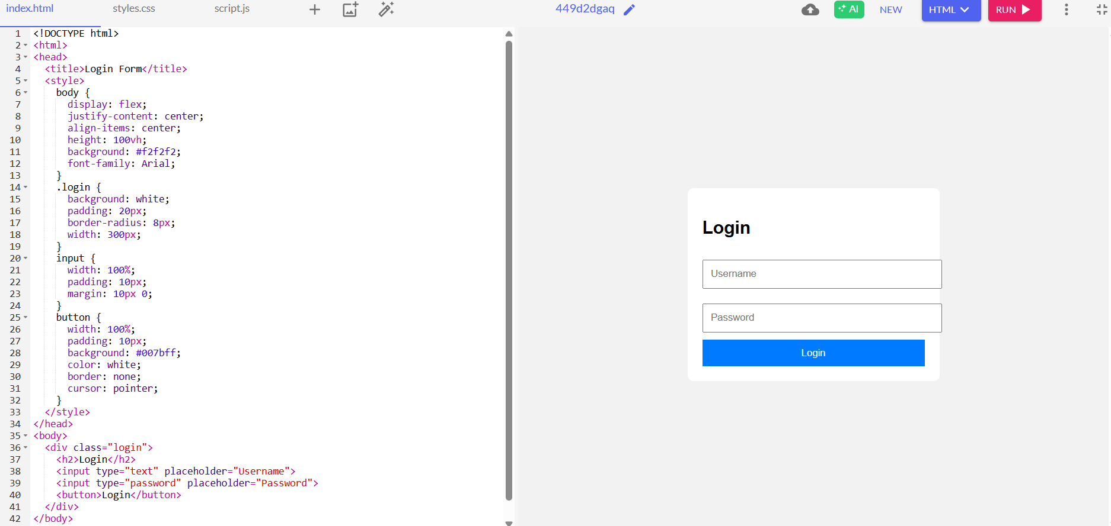

Result:
This practical shows that AI tools like ChatGPT can quickly generate frontend code, reduce manual effort, and save development time.

Advantages of AI Tools in Front-End Development
- Faster UI development
- Reduces repetitive coding work
- Improves productivity
- Helps beginners learn faster
- Improves code quality

Conclusion
AI tools are transforming front-end development by making coding, designing, and testing easier. They help developers work faster and build better user interfaces. Using AI tools in front-end development improves efficiency and productivity, making them an essential part of modern web development.

Future Scope
In the future, AI tools will automate complete UI creation and provide more personalized user experiences.

